INSTALARE AJAX:

1)Vezi daca il are instalat, daca nu se instaleaza node-js

npm -v

2)Il instalam

npm install -g json-server

3) Dupa ce am adaugat db.json ma duc in consola si zic cd desktop

4)

json-server --watch db.json

5)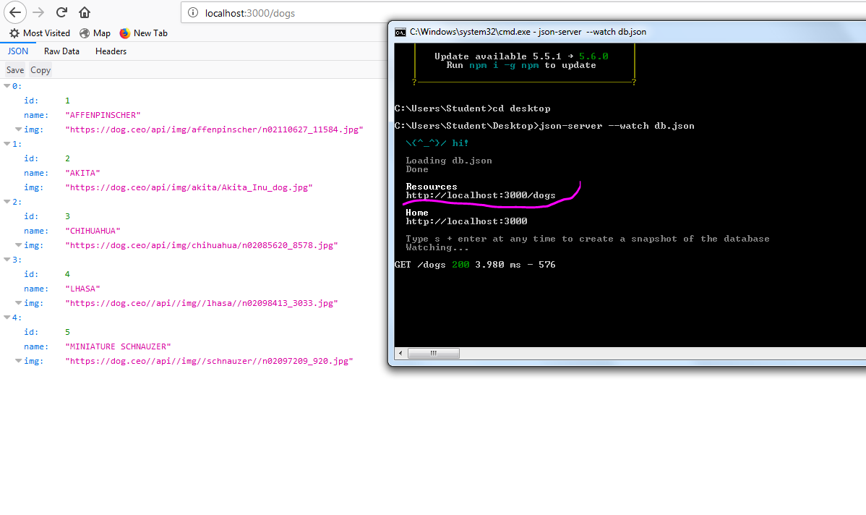

cautam postaman in chrome si ne ajuta pt ajax cu get post …